**AUTONOMOUS VEHICLE**

1. **Hardwares**
   1. Motor

* DC Encoder Motor 12V: [Link](https://shopee.vn/Dajrrhd-Encoder-Motor-Set-CW-CCW-Shaft-DC-Gear-Motors-with-Bracket-Wheel-for-Balance-Car-DC12V-i.156068818.25668808013)
* Encoder: 2 Channel, 333RPM. [Tutorial](https://electricdiylab.com/how-to-connect-optical-encoder-with-esp32/)
* 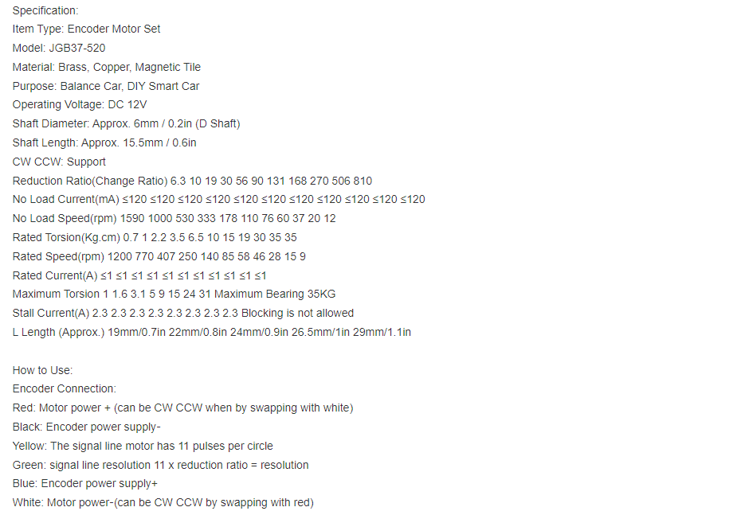Detail:

|  |  |  |  |  |  |  |
| --- | --- | --- | --- | --- | --- | --- |
| Wire color | Red | White | Black | Blue | Yellow | Green |
| Function | 12V+  (MT Power) | 12V-  (MT Power) | 5V-  Encoder power | 5V+  Encoder | A  11pulses | B |

1. ESP32

* Type: ESP-WROOM-32(38Pin): [Link](https://docs.espressif.com/projects/esp-idf/en/stable/esp32/hw-reference/esp32/get-started-devkitc.html)
* Basic tutorials use ESP32: [Link](https://lastminuteengineers.com/handling-esp32-gpio-interrupts-tutorial/#google_vignette)
* Pinout and detail pin function:

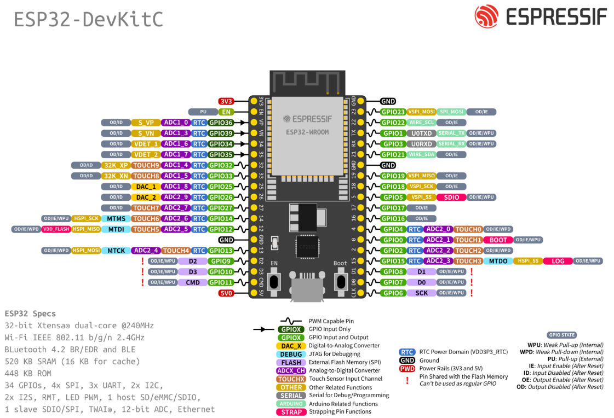[https://docs.espressif.com/projects/esp-idf/en/stable/esp32/hw-reference/esp32/get-started-devkitc.html#](https://docs.espressif.com/projects/esp-idf/en/stable/esp32/hw-reference/esp32/get-started-devkitc.html)

1. IMU

* IMU MPU-6050 Gyroscope Accelerrometer Sensor: [Link](https://randomnerdtutorials.com/esp32-mpu-6050-accelerometer-gyroscope-arduino/)

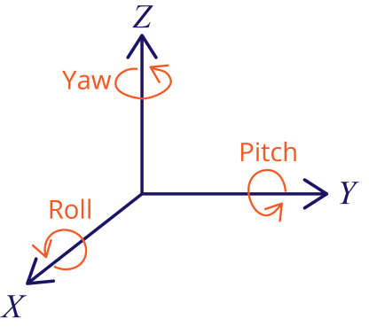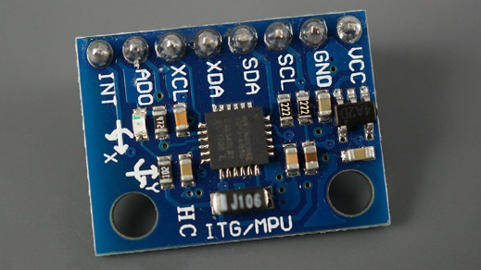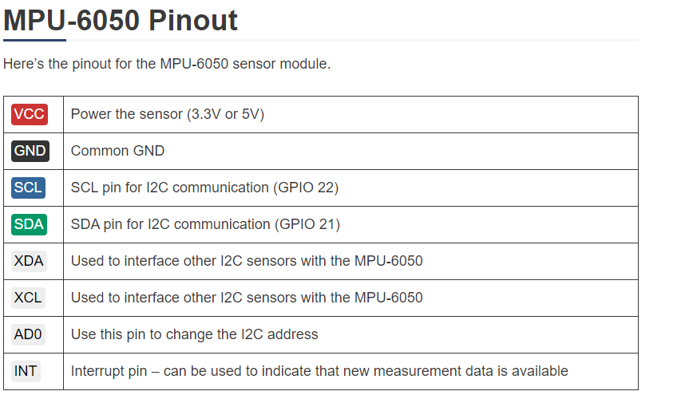

1. Connection diagram design